THE FIRST BEDHAMPTON SCOUT GROUP

Soon after I was appointed Group Scout leader in the 1970’s I was given a pack of 13 magic lantern slides by a scout leader from Rowland’s Castle. These slides depicted scouts in Bedhampton in the early 1900’s. The slides eventually led me to the British Library where I discovered 4 Bedhampton Scout magazines, printed by the scouts themselves.

Below is the front page and editorial of the second magazine showing the Scout Leader as being Fred T Jane who was the founder and author of Jane’s Fighting Ships and author of many other books and publications.

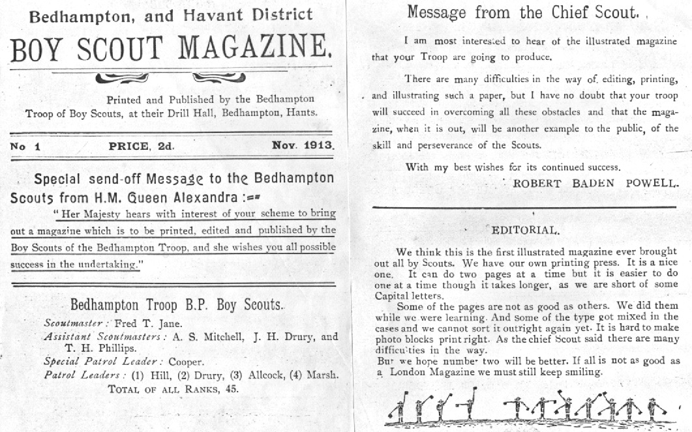

(The date stamp for the receipt of these magazines at the British Library was 29th Feb 1956 and I believe that it was Bert Cooper’s family who sent them. He had told Maurie Hill over the phone that he had discovered something very interesting in his loft. He unfortunately died before he and Maurie could meet to discus his findings.)

Maurice Hill was one of the patrol leaders, see magazine, and when we had an article published in The News he contacted us. We also had contacts from Jim Hankinson in Australia and Tom Stevens of Gosport. Tom Stevens, 80, told us that he had been in the scouts in 1908 and the original scout hut, and it was a hut, was on the bank opposite the Bedhampton level crossing where there are now houses, whereas the headquarters of two thatched cottages, below, was at Brookside alongside Colman’s bakery. Maurie Hill was an invaluable contact as he was able to name nearly all the scouts shown in the photo and told us many stories of Fred Jane and the early scouts.

. 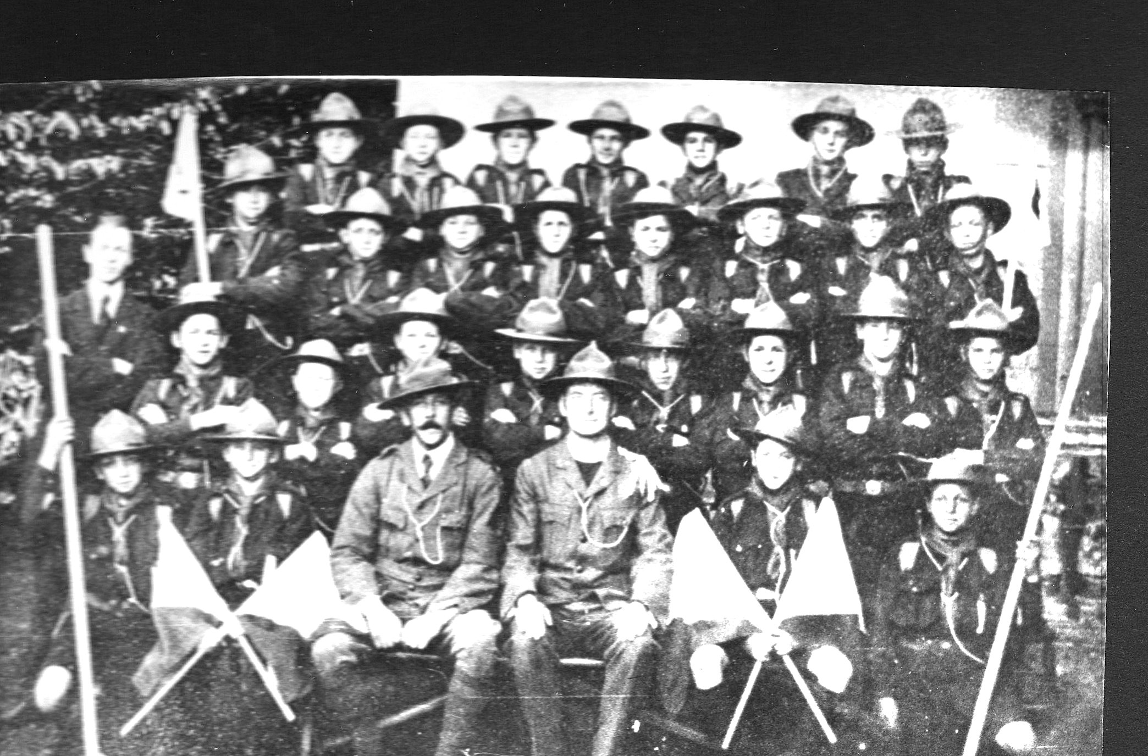
I believe the original is at the Rectory

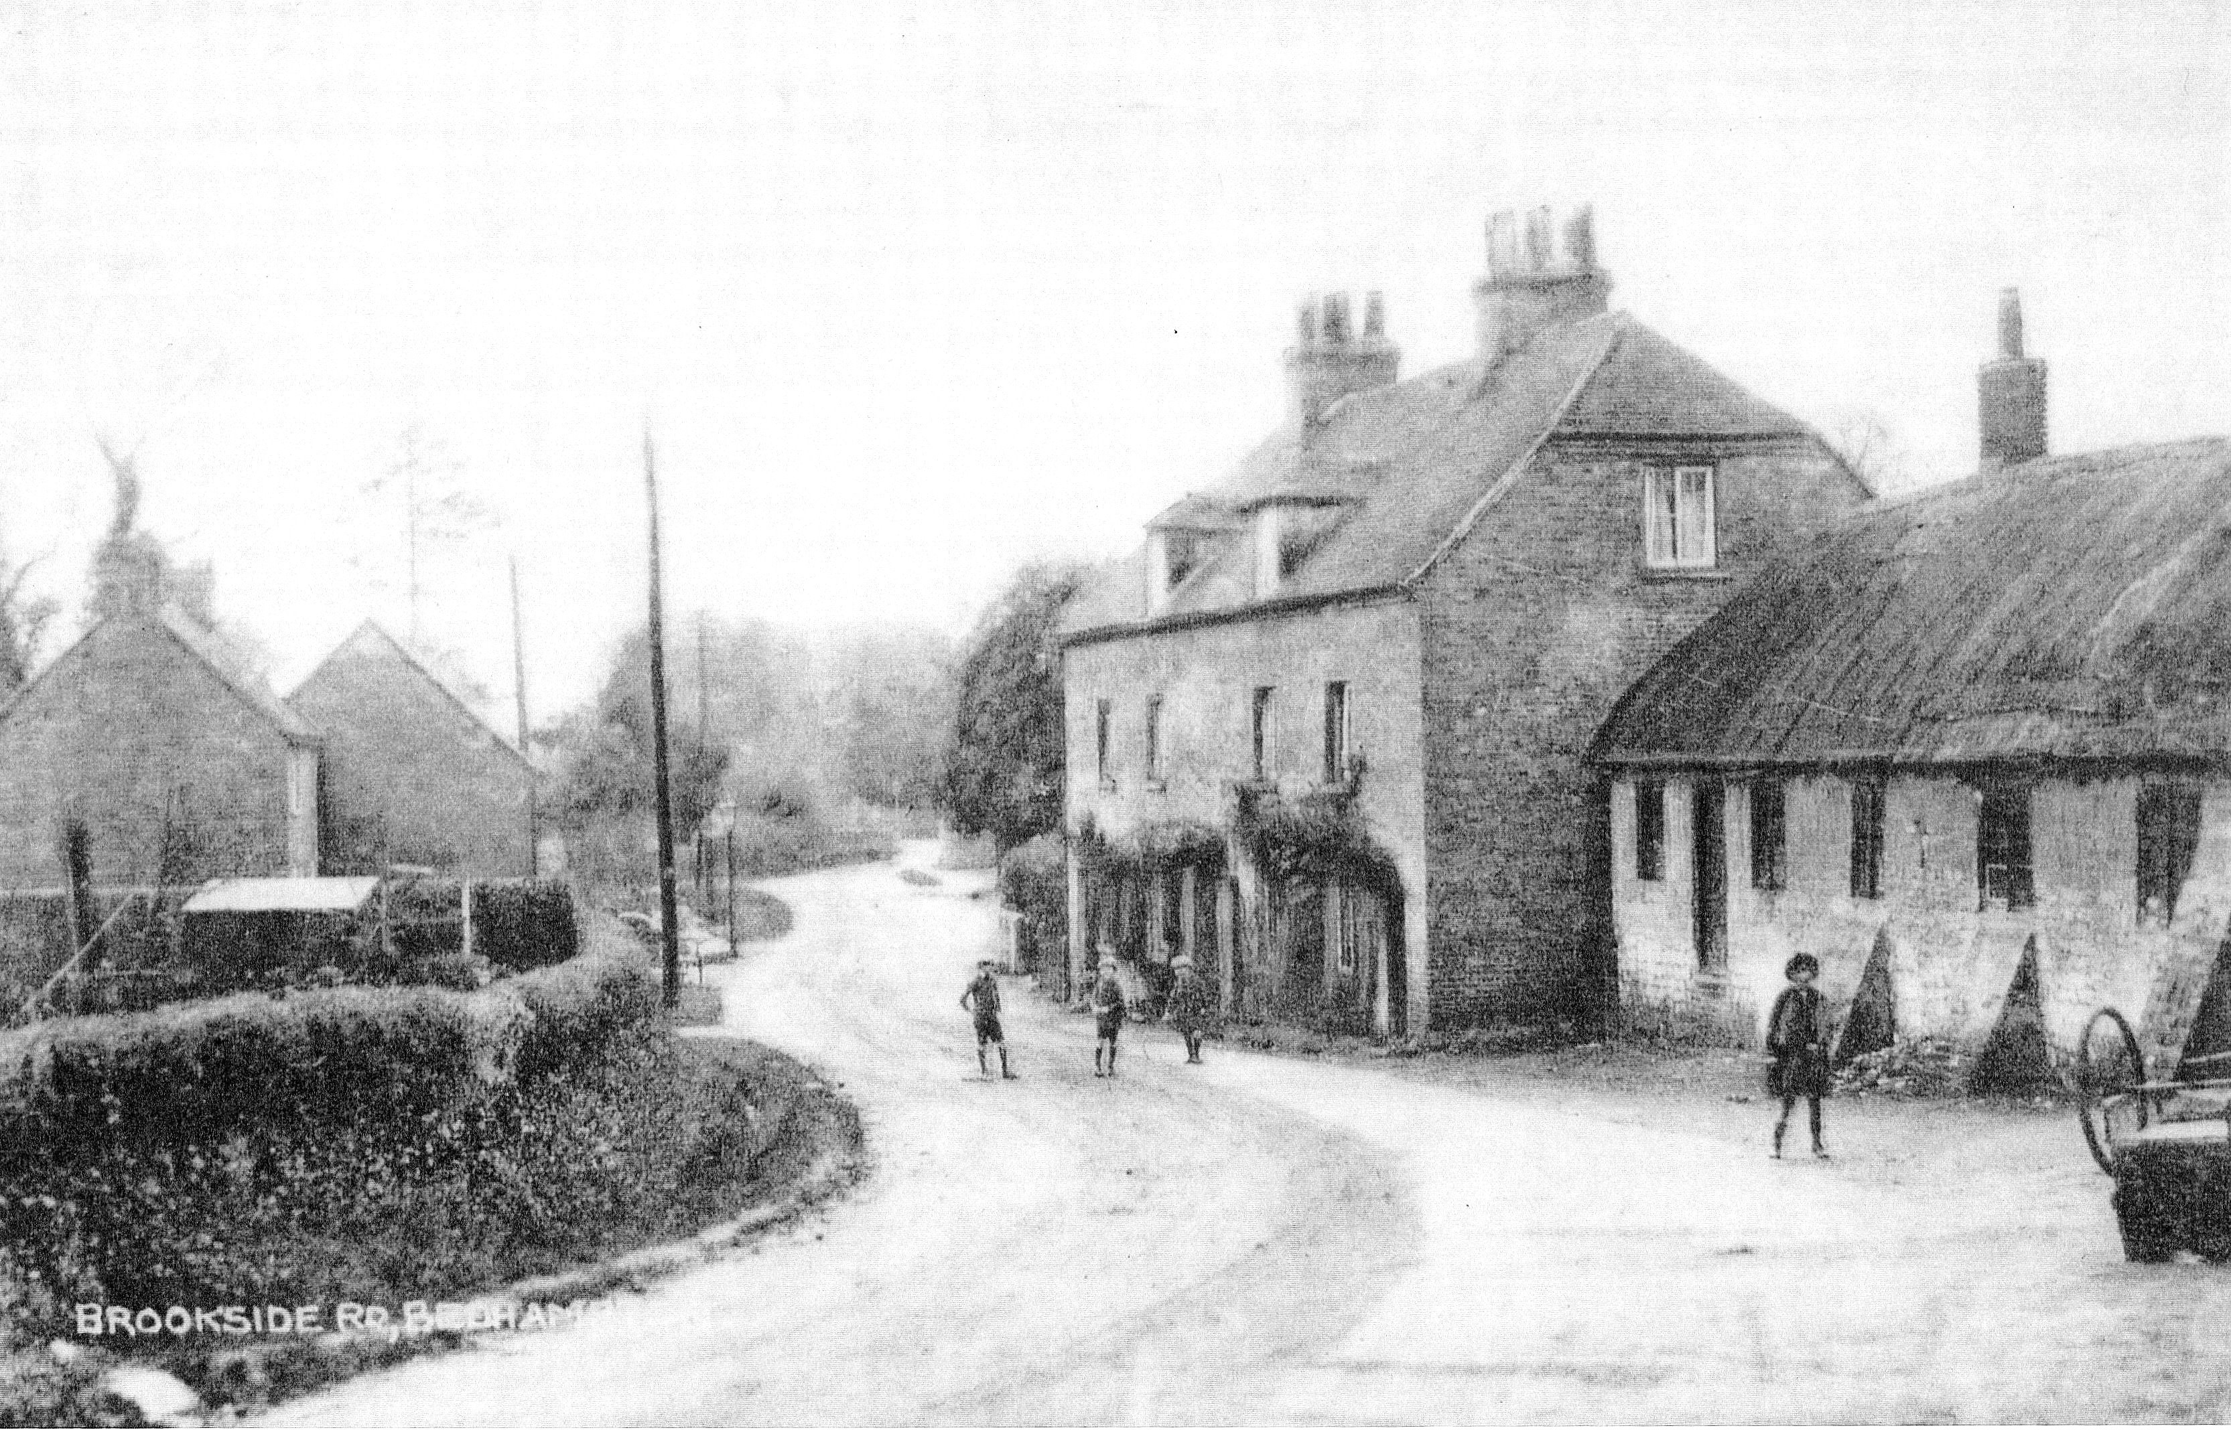

THE THATCHED COTTAGES, RIGHT, WERE THE SCOUT HALL
(Colman’s bakery, not shown, was adjacent)

Maurie also painted a picture, for us, of himself in his Bedhampton Scout uniform. The original painting is now in the Hampshire Museum as are all the 13 slides. Copies of the magazines are in the Havant Museum. He was over 70 years old when he painted this.

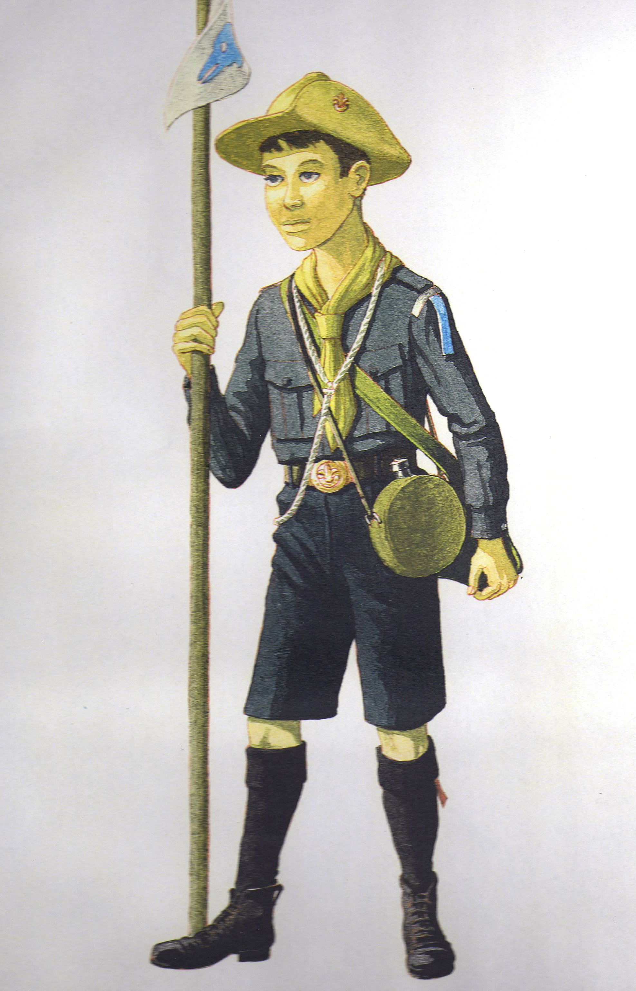

Background history to the formation of the scouts in Bedhampton.

Fred Jane founded and edited his ‘Fighting Ships’ at Southsea in 1898 and also wrote many articles for Pall Mall magazine. During the Boer war Baden Powell was the Colonel in charge of the defence of Mafeking in 1899 and articles were sent from Mafeking to the same magazine. Baden Powell was famed for his defence of Mafeking during the very long siege of 217 days against many thousands of Boers. He had a 5 mile perimeter to defend and only 1,500 untrained soldiers. We therefore have a link between BP and Fred Jane through the Pall Mall magazine and I believe they met when BP returned to England. It was in 1907 that the first experimental camp was held on Brownsea Island and it seems very likely that Fred Jane was inspired to start a Scout Group because of his admiration of BP and it was about that time that he moved to Hill House in Bedhampton since he wanted suitable premises to keep and rear dogs. He was not the original leader but took over when he was not satisfied with the way the scouts were being run.
He bought the two derelict thatched cottages in Brookside and refurbished them. He provided a printing press and all the required type etc. and taught the scouts to print their own magazine. It was the first ever illustrated magazine printed by scouts themselves.
The magazines provide a fascinating insight into the scouts at that time with many surprising stories, including the inspection of the scouts by a Japanese admiral. Jane was involved in a ‘Fighting Ships’ for the Japanese navy at the time so the visit of the admiral is explained. The magazines were sent to many countries and a link was made with scouts in Russia.
Fred Jane had produced a ‘Naval War Games’ and so introduced ‘Battles’ for the scouts with some complicated rules and scoring. These battles were often held behind the Towers at Bedhampton and pictures are shown on the slides.

Entertainment
“ On May 13th (1914) we gave an entertainment at Havant Town Hall which was a great success. The scoutmaster gave a lecture with lantern slides with us at work. After this we drilled by patrols, did trek cart display, ambulance and first aid. The cadets also drilled by patrols. (Mrs Jane ran the cadets) Then all 60 of us came on the platform and did “On The Knees”. Then we all stood to attention and Mrs Jane presented the Troup Flag given to us by her uncle, Mr Jocelyn Ffooks of Sherbourne.”

There are many stories about these Bedhampton Scouts, not forgetting those in the Hampshire Telegraph written by Fred Jane as he was the Telegraph’s naval correspondent.. However one of the stories told me by Maurie Hill was of spy catching at Brockhampton Lane. Apparently any stranger passing through Bedhampton was likely to be questioned by the scouts and in fact the scouts were organised by Jane to provide night patrols around Portsmouth during WW1 because there was a lack of soldiers for that purpose. A few years ago a surprising link to spy catching by the scouts was provided by a TV programme about the early days of MI5 under Kell. In this programme they showed a donation given to a scout group for their work in spy catching and a picture of the group. The same amount of money shows up in the Bedhampton scout magazine as an anonymous donation and the picture shown above of the Bedhampton Scouts is the one shown on the programme and a ‘man from Portsmouth’ was commended on his efforts at spy catching and in fact Fred Jane toured the country, in his famous open Benz, giving advice on this topic

Robert Stevenson Smythe Baden Powell (1857 –1941)

I feel that it is important that all scouts should know a little about their founder and what inspired him to form the scout movement.

His father, professor Baden Powell, was always keen that his children should know about where they lived and took them on forays into the countryside. However he died when BP was 3 years old but the ideas he started were continued by his wife Henrietta and her father Admiral Smythe who was known as Mediterranean Smythe.
BP went to Charterhouse school at Godalming and apparently often vanished at weekends. During these ‘vanishings’ he fended for himself by foraging from his surroundings, catching rabbits etc. With his brothers, headed by the eldest Warrington, he often went on camping tours round Britain and also sailed round Britain and to the continent in Warrington’s boat. On one occasion when their mother had gone on holiday to Llandogo on the River Wye in Monmouth they used a collapsible boat to go 130 miles up the Thames, portaged 40 miles across the Cotswolds to the Severn. They then used the boat to go 7 miles down the Severn to Chepstow and 7 miles up the Wye to Llandogo.

At the age of 18 he joined the 13th Hussars and was sent to the North West Frontier of India, now Pakistan. He found that new recruits were unable to cope with unknown conditions without a leader so he produced a book about army scouting and survival. This book became very popular with boys in this country and many years later he was persuaded to rewrite the book as Scouting for Boys.

Several of the items we now associate with scouting came from his army exploits in Africa. When he was on an expedition in Ashanti, West Africa, to open up a trail for a main force to capture a rebel chieftain at Kumassi he was accompanied by Captain Curtis of the Royal Engineers. Captain Curtis had a long staff, which he used for rough measurements and was also useful to help him jump across streams. This is the staff you see being held by Maurie Hill and was standard equipment for all scouts. He was sent to Matabele to overcome another Zulu chieftain, Dinizulu. Dinizulu was a very large chief and for his ceremonial costume wore thousands of beads made fro Acacia wood. BP overcame Dinizulu and removed the ceremonial beads from him. These beads were used and copies still used, in pairs, for scout leaders’ Wood Badge when they complete their final training. BP also acquired Dinizulu’s Kudo horn, and antelope horn, and this is still at Gilwell and was blown on the 100th anniversary of scouting at Brownsea Island. The hat associated with the earlier scouts, and still worn by traditionalists, was that used by BP when he was appointed to form, and be in charge of, The South African Constabulary and this was considered to be one of BP’s greatest achievements. At Mafeking, during the siege by the Boers, he organised boys, in uniform, to act as runners carrying messages round the various outposts of Mafeking. They were trained by checking that they could deliver messages accurately. Did you do that in Cubs?
I give talks about the early Bedhampton Scouts and Fred Jane and also about BP’s life before scouting. owen.neal@tiscali.co.uk

