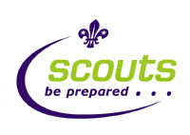
WELCOME TO THE GREATEST PACK IN THE WORLD
(DETAILS ON INVESTITURE INTO 1st BEDHAMPTON CUBS)

Dear Parent/Guardian
It is planned to welcome and invest your Son into the Cub pack on

Tue ___________________________ At approximately 7.45 pm.

Uniform:
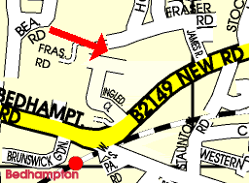
Cubs should (ideally) have a Cub sweatshirt and a 1st Bedhampton scarf. These can be bought from the District Scout shop, Fraser Road (opposite Havant Rugby Club) open Sat 10am – noon and Wednesday 7pm-8pm. Some Cubs like to have an activity polo short for hot weather (fully optional). If there are any problems with uniform please let us know as we can adapt.

The Investiture itself (please encourage Cubs not to worry)
On the night we welcome Parents to Cub forward and take photos. Cubs come forward with their sixer (and assuming they still want to join) make their promise (they repeat after us if needed)

They are then welcomed into the group. We then present them with their scarf and new standard Scout badges (world badge, district/county badge, 1st Bedhampton flash and the moving on award if they have come from Beavers).

Promise, Law and Motto

The Cub Scout Promise:
I promise that I will do my best
To do my duty to God and to the Queen
To help other people
And to keep the Cub Scout Law.

The Cub Scout Law:
Cub Scouts always do their best
Think of others before themselves
And do a good turn every day.

The Cub Scout Motto:
Be Prepared

Badges
On the reverse of this letter is a handy diagram (also linked from www.1stbedhampton.co.uk/cubs ) showing Cub badge positions.

If you have moved up from Beavers, other badges can be transferred from the Beaver at your leisure after the investiture are:
- Joining in Award
- Chief Scouts Bronze Award
- Staged badges (Nights Away, Swimming etc.)
- Activity badges (optional)

Finally
If there are any problems or concerns please contact me,

Nigel Vosper
Assistant Cub Scout Leader
0797 9736459
