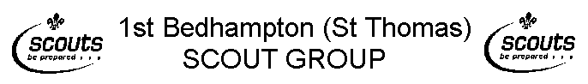
Parent /Guardian information form for Beaver / Cub outings and activities

Childs Name................................................................... ...........Childs Date of Birth............./……./………

Address…………………………………………………………………………………………………………..

Postcode…………………………Tel. Nos.……………………………………………………………………..

The following information is for the benefit of the activity leader.

This section is to be filled in by the parent or guardian of the named Beaver /Cub Scout. It gives authority for a leader to sign on your behalf any papers needed by the medical authorities in case of emergency treatment while in this Scout Group.

Date of last Tetanus…………/………/………

Is he allergic to anything (e.g. aspirin, any particular food or drugs)? ..........................................................

If yes please give details........................................................................................................................................

……………………………………………………………………………………………………………………

Does he use an inhaler? .......................................................................................................................................

Does he need any special dietary needs? ...........................................................................................................

Has he any other special needs? .........................................................................................................................

His National health service number is…………………………………………………………………………

Name of family doctor…………………………………………………..............................................................

Address of doctor………………………………………………………………………………………..............

………………………………………….Postcode………………………Tel. No................................................

Please continue on the back of this sheet if needed, giving any other information which you consider necessary for the activities leader to know.

I will inform you if my son has been in contact with any infectious disease within three weeks prior to an event.

I will inform you of any changes to the above information.

If it becomes necessary for my son to receive medical treatment and I cannot be contacted by telephone or any other means to authorise this. I hereby give my general consent to any necessary medical treatment and authorise the Scouter in charge or their nominee to sign any document required by the medical authorities.

Signature……………………………………………………………………….Date………/………/…………

Note: The medical profession takes the view that parent’s consent to medical treatment cannot be delegated. This view is explicit in the Child Act 1989. Thus medical consent forms have no legal status and a doctor/nurse insisting on the consent of a parent to particular treatment has the right to do so. For this reason we do not recommend that Leaders insist on parents signing the statement above. However, it can be a comfort to medical staff to have general consent in advance from parents or to have a Leader on hand able to sign forms required by medical authorities.

